Overview  Country or Region: United States  Industry: Financial services  Customer Profile  Based in The Dalles, Oregon, Columbia River Bank serves the regional community with 365 employees at more than 20 branches in Oregon and southern Washington.  Business Situation  Columbia River Bank wanted to increase employee productivity and data security by gaining tighter control over information and streamlining workflow processes.  Solution  The bank decided that by upgrading to the 2007 Microsoft® Office system, Windows Vista™ operating system, and Microsoft Exchange Server 2007, it could not only achieve its goals, but also cut some costs.  Benefits  - Increased user productivity  - Increased IT staff productivity  - Enhanced security  - Ability to maintain regulatory compliance  - Reduced costs |  |  | “We’ve been able to shorten the amount of time that it takes for us to deploy the systems from 4 hours per computer to just 15 minutes—that’s 16 times faster—which translates to a migration savings of $46,875.”  Nathan Church, Vice President and Information Technology Manager, Columbia River Bank
 |  |  | As a financial institution, Columbia River Bank promises to provide fast service to customers and a secure banking environment. The bank constantly looks for innovative ways to streamline operations and opportunities to safeguard against potential risks. To those ends, the bank recently upgraded to the 2007 release of the Microsoft® Office system, the Windows Vista™ operating system, and Microsoft Exchange Server 2007. The bank also is conducting a proof of concept that uses Microsoft Office SharePoint® Server 2007 to automate workflow. The upgrades have increased productivity for users and IT staff alike because the new systems make it easy to locate and share information and to use automation to trim timelines. Plus, the new environment increases data security and is helping lower costs by an estimated U.S.$86,000 by eliminating the need for third-party applications.
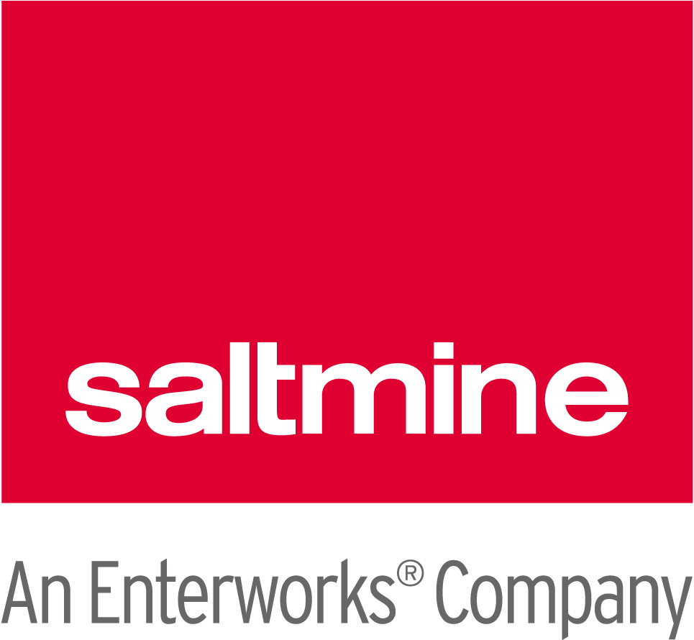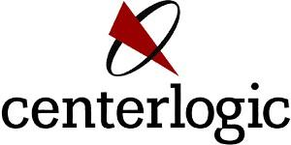 |  |  | 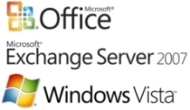

Situation
Almost 30 years ago, Columbia River Bank opened its first office in The Dalles, Oregon. Since then, the bank has steadily grown, both by opening new branches and by merging with other community banks. Now one of the largest community banks in the Pacific Northwest, Columbia River Bank strives to expand services to customers while retaining its community focus. In addition to traditional banking services, Columbia River Bank offers an array of others, from health savings accounts to retirement accounts, with 20 full-service branches and three limited-service branches in retirement homes.

Part of the reason that the bank has experienced continued expansion and success is that it relies on advances in computing technology to overcome many of the typical growing pains for organizations. “Because we place an emphasis on technology, we’re able to be agile when it comes to opening new branches, and we’ll be ready if we acquire another bank,” says Nathan Church, Vice President and Information Technology Manager for Columbia River Bank. “We don’t have to spend as much time to set up new branches, due to our investments, and we have standard processes so that new branches can ‘create the experience’ for our customers.”

Columbia River Bank makes it a practice to stay current with the latest software technology. The company has been using Microsoft® Office Professional Edition 2003 and the Windows® XP operating system for its 425 workstations and 75 portable computers, and Microsoft Exchange Server 2003 for its messaging and collaboration server. “We’ve been happy with our IT environment, but we’ve also been looking forward to advancements that could help us increase security and automate some of our internal processes,” says Church.
For instance, the bank used Microsoft Office SharePoint® Portal Server 2003 for its intranet to centrally house forms for everything from vehicle rental requests to account analysis documents. However, employees had to print them, manually fill them out, and then route them through interoffice mail to the most appropriate people for approval. The bank wanted to address the inefficiencies of its processes to improve its workforce productivity.

“Many of the forms require specific approvals, but new employees didn’t always understand the approval process,” explains Church. “For some processes, such as expense reimbursement, employees needed to send requests that were under a certain dollar amount to one person, but requests that were over a certain amount needed to be approved by someone else. In some cases, a simple request would take way too long to fulfill, and managers would lose valuable time trying to track expense-related data.”

Accuracy also was an issue. Because employees were manually filling out forms, there was no field verification, so writing information into the wrong box wasn’t discovered until later in the approval process, requiring communication between the accounting department and whoever filled out the form. Inaccurate data entries also occurred, due to difficulty deciphering the handwriting on the forms.

Because some of the forms include sensitive customer-related information, Columbia River Bank wanted to find a way to transfer the documents with less risk. “Even though it had never been a problem, we had some security concerns about couriering the documents between branches and our main office,” says Church. “We thought that we could automate the process and remove altogether the risks associated with a paper-bound system.”
Security concerns weren’t limited to paper, however. The bank wanted to take advantage of available measures that would further safeguard customers’ information and maintain regulatory compliance, in particular with the Gramm-Leach-Bliley Act, the Sarbanes-Oxley Act of 2002, and Federal Financial Institutions Examination Council (FFIEC) guidance. “We have 75 portable computers and we wanted to reduce their susceptibility to viruses and other malicious software, plus provide enhanced security to guard against unauthorized access without getting in the way of our users,” says Church. “Also, we needed to make it easier for mobile employees to more directly connect to information and each other.”

Solution
Initially, Columbia River Bank considered adding third-party tools to its existing environment for such functionality as security management and encryption and the tracking of expenses. “Adding two or three third-party applications would have given us most of the capabilities that we needed, but it also would have meant a lot more to manage,” says Church.
“Adding two or three third-party applications would have given us most of the capabilities that we needed, but it also would have meant a lot more to manage.”
Nathan Church, Vice President and Information Technology Manager, Columbia River Bank

Instead, Columbia River Bank determined that upgrading its software to the new Microsoft offerings could provide the functionality that it needed—plus other advantages—without the expense or frustration of supporting applications from multiple vendors. The bank decided to upgrade its productivity tools, client operating system, and back-end messaging system, moving to the 2007 release of the Microsoft Office system, the Windows Vista™ operating system, and Microsoft Exchange Server 2007, respectively.

For guidance with the different upgrade projects, the bank turned to the Microsoft partner network for expertise, choosing Saltmine and Centerlogic, both of which are Microsoft Gold Certified Partners. “Our partners have been wonderful in helping us bring our IT projects to fruition,” says Church. “They have so much experience in knowing how to make migration projects successful, and we’ve had the benefit of that knowledge throughout the process.”

Upgrading Workflow Capabilities
For the Microsoft Office system upgrade, Columbia River Bank worked with Saltmine to define and design a proof of concept (POC) to test the workflow capabilities of Microsoft Office SharePoint Server 2007, just as it had worked with Saltmine for its original SharePoint Portal Server 2003 implementation.

The bank determined that its process for expense reimbursement made the most sense for the POC. Saltmine set about configuring a solution based on SharePoint Server 2007 that required no custom coding so that the bank could easily adapt the solution to improve its other processes. Says Ryan Peck, Project Manager for Saltmine, “We wanted to give Columbia River Bank a solution that provided its internal staff with the full ability to create and customize workflows themselves.” The new solution relies on the integration between Office SharePoint Server 2007, Excel® Services, and the Microsoft Office InfoPath® 2007 information-gathering program to provide forms and dynamic spreadsheets to users from any Web browser.

The new process for expense reimbursement also is integrated with the company’s general ledger, the Active Directory® directory service structure, and the Microsoft SQL Server™ 2005 database that is used by its human resources department. When an employee needs to be reimbursed for an expense, he or she downloads and electronically fills out the appropriate form, which is automatically routed through an approval process based on the type and amount of the expense. Upon approval, the reimbursement request automatically uploads to the general ledger, and the funds are deposited into the employee’s account.

The bank plans to extend the workflow capabilities to other internal processes and to use Office SharePoint Server 2007 for tighter coordination of the teams that work on everything from software implementation projects to branch openings through the use of collaboration workspaces. In addition, the bank will complete an enterprisewide upgrade of its workstations and portable computers to Microsoft Office Professional 2007 by March 2007.

Upgrading the Client Operating System
Columbia River Bank brought in Centerlogic to help develop and roll out the bank’s Windows Vista Enterprise operating system upgrade to a pilot group of users. Centerlogic helped speed the deployment and ease geographical logistics by using tools such as the Microsoft Solution Accelerator for Business Desktop Deployment (BDD) 2007 and the Microsoft Systems Management Server 2003 Operating System Deployment feature pack.

As of October 2006, 15 users who represent a cross-section of the organization already are using Windows Vista, and Columbia River Bank anticipates that the operating system will be deployed to all of its users by March 2007.

Upgrading the Messaging System
Also in partnership with Centerlogic, Columbia River Bank has deployed Exchange Server 2007 on the Windows Server® 2003 Enterprise x64 Edition operating system. The bank plans to deploy an additional server in the future, when it implements a unified messaging solution in conjunction with an existing Voice over IP (VoIP) phone system from Cisco. When combined with the bank’s telephony system, the unified messaging features in Exchange Server 2007 will make it possible for bank employees to store voice mail in their inboxes, listen to their voice mail by clicking a button on an embedded player, view the faxes that are routed to their inboxes, record out-of-office messages with Microsoft Office Outlook® Web Access, listen to e-mail messages that convert text to speech, and use a standard telephone to access their Exchange Server mailbox from any location.

Benefits
For Columbia River Bank, adopting a new desktop infrastructure and messaging system has heightened employee productivity and enhanced security and regulatory compliance. The system upgrades combine to increase overall operational efficiency and lower costs, especially when compared to deploying and maintaining third-party solutions.

Increased User Productivity
According to the results of the POC, each reimbursement to be submitted under the new expense reimbursement system will take an average of 45 percent less time to prepare than with the old method, saving U.S.$450 per month. Approvers and those in the accounting department will no longer need to return forms to employees due to errors in filling out the forms, because the field verification capabilities in Office InfoPath 2007 will ensure that employees enter appropriate information the first time around. The bank hopes to see similar results as it automates other processes in the future.

Mobile users also can take advantage of the bank’s upgraded environment. “The fact that the POC solution is Web based is making it faster and easier for employees to take care of their reimbursements because they can do it from anywhere,” says Church, “and that convenience will extend to our other processes once we expand the solution.”

With the combination of Windows Vista and Office SharePoint Server 2007, Columbia River Bank employees now can locate more-relevant documents, which means that users are more likely to reuse existing information rather than start from scratch. “With the advanced search capabilities that SharePoint Server 2007 and Windows Vista provide, our users are saving time and effort by making the most of what we’ve already got,” says Church.

Several elements of the new solution will streamline operations and help keep employees efficient. In addition to the process improvements, the bank’s users also are finding that the user interface (UI) of Microsoft Office Professional 2007 is a helpful productivity tool. “The new Ribbon in Office Professional 2007 saves a lot of time by having my most commonly used commands at my fingertips. It’s really intuitive,” says Anthony Ranslam, IT Support Technician for Columbia River Bank. “Several of our pilot users have told me how much they love that feature, too.” The Microsoft Office Outlook 2007 messaging and collaboration client, which is included in Office Professional 2007, contains new time-saving features, as well, such as integrated Instant Search and one-click Attachment Preview. Says Ranslam, “The task bar is very useful for seeing everything I need to do at a glance.” Office Outlook now connects to SharePoint sites’ calendars, documents, contacts, and tasks, providing users with full editing capabilities.
“The new Ribbon in Office Professional 2007 saves a lot of time by having my most commonly used commands at my fingertips. Several of our pilot users have told me how much they love that feature, too.”
Anthony Ransalm, IT Support Technician, Columbia River Bank

Employees traveling between bank branches also can get more done thanks to the improved UI and functionality in Outlook Web Access that enables mobile workers to conveniently send and receive e-mail messages, view calendars, and use task lists. In fact, Columbia River Bank is considering implementing RPC over HTTP capabilities to spare its remote workers the time, and often frustration, it takes to use the virtual private network (VPN) process to securely connect to the network from outside.

Increased IT Staff Productivity
From an IT perspective, upgrading both client and messaging systems has given Columbia River Bank the ability to manage its environment more efficiently. “With our branches spread across Oregon and Washington, we don’t have enough staff to deploy systems onsite, so we’re really excited about the zero-touch deployment capabilities that we’ve been using with Microsoft Systems Management Server 2003 and Windows Vista. We’ve been able to shorten the amount of time that it takes for us to deploy the systems from 4 hours per computer to just 15 minutes—that’s 16 times faster—which translates to a migration savings of $46,875,” says Church. “And the deployment tools even maintain user settings, so we don’t have to spend follow-up time readjusting them.”

After the deployment is complete, the bank expects to save IT time in supporting its upgraded environment as well. “The enhanced administrative capabilities give us more granular control. We can use Group Policies to manage features and help us control the desktop but still give users access to all the things that they need. We get to keep our users happy while protecting them from inadvertently bringing anything harmful into the network that IT then has to handle,” says Church. “Also, we’re going to be able to manage the systems with our existing tools, such as Active Directory, so there will be less time required on both sides for training, too. We’re proud to have standardized on Microsoft technologies and have found it’s much easier to bring new IT staff up to speed because of it.”
Enhanced Security and Ability to Maintain Regulatory Compliance
Columbia River Bank does all that it can to safeguard its customer-related information, documents, and network. By using the automated workflow capabilities in Office SharePoint Server 2007, the bank is taking better care of internal documents because they never need to be printed or shuttled from branch to branch.

From a network security standpoint, the bank is protecting itself—and its customers—from those with malicious intent by using such features as Windows BitLocker™ Drive Encryption, which prevents an unauthorized user from viewing the files on a lost or stolen computer. The bank also is using Windows Defender to help safeguard its users’ computers from pop-ups, slow performance, and security threats caused by spyware and other unwanted software; and Network Access Protection in Windows Vista, which checks a computer to ensure that its antivirus software is up-to-date and that it is virus-free before allowing it to join the network. “I love the fact that all of those security features exist natively in Windows Vista,” says Church.
"Everywhere I look, I see workflow needs that can be streamlined through formalized processes—and now we have the tools to make that happen.”

Nathan Church, Vice President and Information Technology Manager, Columbia River Bank

Columbia River Bank also has implemented multifactor authentication for users logging on to Outlook Web Access, enhancing the security of user communications. In addition, the bank’s new messaging system helps it adhere more closely to the security regulations governing financial institutions’ communications. For instance, by using a wizard in the Exchange Management Console or the command line in the Exchange Management Shell, the bank’s IT systems administrators can write rules that prohibit communication between members of distinct distribution lists, require encrypted delivery whenever a message contains confidential information identified by text pattern matching, append a disclaimer to any message being sent externally, or include the bank’s compliance personnel on the “Bcc” line any time a specific phrase appears in a message.

Reduced Costs
Because of the native capabilities of the upgraded technologies, Columbia River Bank can avoid deploying and managing third-party applications and can simplify its environment. “For expense reporting alone, we either would have had to hire another part-time employee to enter and track reimbursements as the bank continues to grow or pay for the setup of a third-party application, plus a hefty monthly fee to maintain it,” says Church. “Also, by taking advantage of our new easier ways of enabling mobile messaging, we can stop supporting and maintaining most of our VPN accounts.”

Concludes Church, “Altogether, upgrading to the 2007 Office system, Windows Vista, and Exchange Server 2007 has helped Columbia River Bank save about $86,000. We’re conserving resources yet providing improved service to customers and users. Everywhere I look, I see workflow needs that can be streamlined through formalized processes—and now we have the tools to make that happen. The more that we apply our new technical capabilities to our work patterns, the more value we’ll see.”
Microsoft Office System
For More Information
For more information about Microsoft products and services, call the Microsoft Sales Information Center at (800) 426-9400. In Canada, call the Microsoft Canada Information Centre at (877) 568-2495. Customers who are deaf or hard-of-hearing can reach Microsoft text telephone (TTY/TDD) services at (800) 892-5234 in the United States or (905) 568-9641 in Canada. Outside the 50 United States and Canada, please contact your local Microsoft subsidiary. To access information using the World Wide Web, go to: www.microsoft.com

For more information about Saltmine products and services, call (206) 284-7511, or visit the Web site at: www.saltmine.com

For more information about Centerlogic products and services, call (503) 288-8886, or visit the Web site at: www.centerlogic.com

For more information about Columbia River Bank products and services, call (877) 272-3678, or visit the Web site at: www.columbiariverbank.com

This case study is for informational purposes only. MICROSOFT MAKES NO WARRANTIES, EXPRESS OR IMPLIED, IN THIS SUMMARY.

Document published November 2006

Software and Services  - Microsoft Office  - Microsoft Office Professional 2007  - Microsoft Office InfoPath 2007  - Microsoft Office SharePoint Server 2007  - Microsoft Server Product Portfolio  - Microsoft Exchange Server 2007  - Microsoft SQL Server 2005  - Microsoft Systems Management Server 2003 Operating System Deployment feature pack  - Windows Server 2003 Enterprise x64 Edition | - Windows Vista Enterprise  - Technologies  - Active Directory  - Excel Services  - Microsoft Office Outlook Web Access  Hardware  - IBM eServer xSeries 346 server computers  Partners  - Saltmine  - Centerlogic

The Microsoft Office system is the business world’s chosen environment for information work, providing the programs, servers, and services that help you succeed by transforming information into impact.

For more information about the Microsoft Office system, go to:
www.microsoft.com/office

Microsoft Exchange Server 2007
For more information about the Microsoft server product portfolio, go to:
www.microsoft.com/servers/default.mspx

For more information about Microsoft Exchange Server, go to:
www.microsoft.com/exchange

Windows Vista
Windows Vista can help your organization use information technology to gain a competitive advantage in today’s new world of work. Your people will be able to find and use information more effectively. You will be able to support your mobile work force with better access to shared data and collaboration tools. And your IT staff will have better tools and technologies to enhance corporate IT security, data protection, and more efficient deployment and management.

For more information about Windows Vista, go to:
www.microsoft.com/windowsvista

